Project Title: IRANIAN CHURN ANALYSIS
PROJECT OBJECTIVES:
•To identify how customer dissatisfied, service usage levels, and specific demographics drive subscription cancellations. • Implement predictive modelling to flag subscribers at high risk of leaving. • Evaluate variables such as call failures, complaints, subscription length, and frequency of use to understand engagement patterns. • Provide actionable insights for telecom operators to design targeted onboarding and pricing interventions.
PROJECT Dataset:
Rows : 3150
Columns:13
Data Source: UCI MACHINE LANGUAGE REPOSITORY
Missing value: No
Duplicated values :300
EDA:
In eda the duplicate values are founded and removed.
The Correlation is find for the numeric values. The Status column is changed into the string datatype.
Univariate Analysis:
1.Target Variable (Status/Churn) Imbalance Profile(countplot)
• Why it is used: To visually evaluate the baseline macro-split of the prediction column (Churn).
• Interpretation: Out of 3,150 customer traces, ~84% are labeled Retained (0) while ~16% are labeled Churned (1).
• Business Insight: The company is suffering an acute structural attrition problem. However, because the dataset displays an 84/16 class imbalance, a predictive model could lazily guess "Retained" every time and look 84% accurate. Data engineering teams must discard default Accuracy metrics and use Recall or F1-Score to train predictive algorithms.
#2: Seconds of Use: (Histogram)
• Why it is used: To evaluate continuous feature range limits and uncover underlying geometric shapes.
• Interpretation: The visualization forms a steep, heavily right-skewed curve peaking dramatically at 0 to 1,500 seconds, with an exponentially shrinking tail.
• Business Insight: The overwhelming majority of subscribers display low-to-moderate monthly calling traffic. A tiny tier of hyper-active premium users commands the long right tail.
# 3: Frequency of SMS Box Plot:
• Why it is used: To calculate the central median line and explicitly flag the density of extreme distribution outliers.
• Interpretation: The box boundary is compressed firmly toward the lower limits, while dozens of discrete data points float far past the maximum interquartile range (IQR) line.• Business Insight: While normal clients text sparingly, specific enterprise accounts or automated text bots skew raw distribution bounds. These maximum outliers must be trimmed using Tukey’s fences or IQR capping to ensure baseline model stability.
4: Subscription Length Tenure Distribution:(Histogram)
• Why it is used: To calculate the central median line and explicitly flag the density of extreme distribution outliers.
• Interpretation: The box boundary is compressed firmly toward the lower limits, while dozens of discrete data points float far past the maximum interquartile range (IQR) line.
• Business Insight: While normal clients text sparingly, specific enterprise accounts or automated text bots skew raw distribution bounds. These maximum outliers must be trimmed using Tukey’s fences or IQR capping to ensure baseline model stability.
5: Customer Value Violin Plot:
• Why it is used: To observe both the central trend density and the full continuous dispersion shape simultaneously.
• Interpretation: The violin shape has a thick bulge at the lower tier but reveals an extended, needle-like tail stretching up into premium customer valuation spaces.
• Business Insight: While the general population generates steady, low-yield returns, a narrow segment of premium clients represents the real financial cushion of this provider. Losing even a few of these users will hit overall profitability hard.
6: Call Failures Discrete Count Plot:
• Why it is used: To observe how often technical dropouts occur across the user base.
• Interpretation: An overwhelming majority of customer lines cluster at exactly 0, 1, or 2 total drops, with a tiny fraction suffering 4 or more dropped calls.
• Business Insight: The network infrastructure is broadly stable at a macro level. This baseline distribution allows the business to isolate standard operational noise from accounts experiencing true localized antenna or hardware issues.

BIVARIATE ANALYSIS
1. # Complains vs Churn Stacked Percentages
• Why it is used: To examine how a categorical service event impacts customer retention.
• Interpretation: When Complains = 0 (No complaint), churn is lower than 5%. However, when Complains = 1, over 80% of those subscribers churn.
• Business Insight: A recorded consumer complaint is a near-definitive leading indicator of attrition. This highlights extreme delays or poor resolution quality in customer service teams. Immediate, automated system routing should trigger retention protocols the moment a complaint file is opened.
2: Seconds of Use Density Split by Churn
• Why it is used: To track continuous calling duration variances between retained and churned cohorts.
• Interpretation: The "Churned" density curve forms a tall, narrow spike right at 0 seconds, while the "Retained" curve exhibits a broad, active usage profile.
• Business Insight: This provides clear evidence of "Silent Churn." Subscribers rarely drop their service abruptly on high-usage days; instead, they gradually scale down their activity over weeks before abandoning the SIM entirely.
3: Churn Probability by Charge Tier:
• Why it is used: To measure how different spending brackets correlate with customer churn.
• Interpretation: Churn probability is high at the lowest billing tiers (0–2), levels off in mid-tier groups, and shows a slight tick upward at the highest tier (9).
• Business Insight: Low-yield prepaid accounts are highly transactional and switch carriers over small price differences. The slight tick upward at tier 9 reveals that top-paying premium accounts will also defect if their customer service expectations are not met.
4: Subscription Length Box Plot Split by Churn:
• Why it is used: To track whether long-term tenure provides protection against churn.
• Interpretation: The median box boundary for churned users is noticeably lower, focusing heavily within the fragile 12-to-18-month tenure zone.
• Business Insight: First year and a half of a customer's contract lifecycle is the most vulnerable window. Accounts that cross the two-year milestone exhibit much higher baseline stability due to habits, automatic payment setups, or ecosystem lock-in.
5: Call Failures Impacting Churn Rate Point Plot:
• Why it is used: To determine the exact relationship between technical issues and customer defection.
• Interpretation: The line graph trends upward: as call drops climb past 3 or 4 events, the baseline historical probability of churn rises in tandem.
• Business Insight: Technical service drops are a direct catalyst for customer attrition. Engineering teams can use this 3-to-4-failure threshold to prioritize cell tower maintenance before local users begin to defect.
6: Customer Value Distribution Split by Churn:
• Why it is used: To inspect the financial footprint of lost subscribers compared to retained ones.
• Interpretation: The churned cohort forms a wide bulge at the lowest tier of the Customer Value metric, while the retained segment is distributed much higher.
• Business Insight: While the majority of churning accounts come from low-yield tiers, the business must carefully isolate any high-value exceptions to prevent major revenue hits.
MULTIVARIATE ANALYSIS
• What it is: The simultaneous inspection of three or more data dimensions.
• Why it is used here: To map complex feature interactions, eliminate data redundancies, and uncover high-value financial exposure risks
1: Correlation Heatmap Matrix
• Why it is used: To uncover hidden mathematical connections across the entire dataset.
• Interpretation: The heatmap highlights an extreme, near-perfect correlation coefficient of +0.98 between Seconds of Use and Frequency of Use.
• Business Insight: Keeping both variables introduces severe multicollinearity into the modelling pipeline.This inflates coefficient variances and scrambles feature importance rankings. Preprocessing pipelines must drop Frequency of Use entirely to ensure structural model stability
2: High-Value Revenue Attrition Scatter Plot:
• Why it is used:To map three columns at once (Customer Value on Y, Charge Amount on X, and Churn via color coding).
• Interpretation: While most churn markers sit in low-value areas, a distinct cluster of churned points appears in the upper-right quadrant (High Tiers 7–9 paired with high Customer Value).
• Business Insight: This quadrant represents the VIP Attrition Zone. Although low-value prepaid users account for the highest headcount of churn, losing a single high-value subscriber from this zone causes more financial damage than losing a dozen low-tier lines. Retention budgets should be heavily focused here.
3: Usage Redundancy Scatter Plot:
• Why it is used: To visually confirm the redundancy discovered in the correlation matrix.
• Interpretation: The data points form a perfectly straight diagonal line, with churn markers clustered heavily near the origin.
• Business Insight: This tight linear alignment proves that call count and call duration change at the exact same rate. Keeping both columns adds zero new predictive power to machine learning models.
4.Grouped Box Plot (Complains x Seconds of Use by Status):
• Why it is used: To track how complaints and usage metrics interact to influence churn behaviour.
• Interpretation: Even when accounts maintain solid usage levels, the introduction of a complaint flag (Complains = 1) shifts their distribution directly into the churn zone.
• Business Insight: High network usage does not shield an account from churn if they encounter service issues. A single unaddressed operational issue can cancel out months of customer loyalty, making quick resolution critical.
5: Channel Preference Scatter Plot (Voice vs SMS):
• Why it is used: To determine if customers shift from voice calls to text messaging before churning.
• Interpretation: Churn markers are heavily concentrated near the origin (0 for both voice seconds and SMS counts), showing low activity across both channels.
• Business Insight: Customers do not typically replace phone calls with texting before they leave; they stop using both services simultaneously. Total communication decay across all channels is a clear sign of impending churn.
6: Service Failure Trend line across Account Lifetimes:
• Why it is used: To analyse how technical dropouts affect customer retention across different tenure lengths.
• Interpretation: Retained users show a flat, low failure line across all tenure brackets. In contrast, churned users show high call failure lines regardless of how long they have been subscribed.
• Business Insight: Long-term loyalty does not protect an account from technical issues. If a 3-year subscriber suddenly faces a spike in dropped calls, they are just as likely to leave as a new user. Technical quality metrics must be maintained across all accounts, regardless of tenure.
Types of Analysis

1.Descriptive Analytics:What Happened?
Descriptive analytics summarizes historical data points to establish baseline operations over the initial 9-month behavioral window.
• The Macro Attrition Profile (Univariate chart1): The dataset establishes a baseline churn rate of approximately 16.0% (504 churned customer records vs. 2,646 retained customer records).
• Extreme Consumer Skewness (Univariate chart 2 & Univariate chart 3): Continuous traffic metrics like Seconds of Use and Frequency of SMS exhibit dramatic right-skewed decay distributions. The top 15% to 20% of premium power-users drive the vast majority of cellular airtime, while the average baseline consumer maintains a tiny usage footprint.
• Operational Friction Volume ( Univariate Chart 6): Formal customer complaints are rare at a macro level, with only roughly 10% of the entire database registering a complaint flag (Complains = 1). Technical network dropouts are low, with most lines clustering at 0 to 2 total Call Failures.
2.Diagnostic Analytics:Why Did It Happen?
Diagnostic analytics dives into feature interactions to isolate the root causes and leading behavioural indicators behind customer churn.
• The Complaint Risk Threshold (Bivariate Chart1): Crossing complaints directly against customer status reveals a severe system failure: over 80% of subscribers who lodged a formal complaint ended up churning. Conversely, less than 5% of non-complaining accounts abandoned the network.

• The "Silent Churn" Lifecycle(Bivariate chart 2 & Multivariate chart 5): Churned subscribers cluster heavily at near-zero traffic limits for both calling seconds and text counts during the monitoring window. Customers do not typically cancel subscriptions instantly on high-activity days; they scale down their network presence over weeks before abandoning the SIM entirely.

• Service Drop Limits(Bivariate chart 5 & Multivariate chart 6): Plotting dropped call rates shows that when a customer experiences 3 or more call failures, their baseline probability of churning climbs sharply. Long-term customer loyalty provides no shield against technical network issues; if a 3-year subscriber encounters sudden connection drops, they defect at the exact same rate as a new user.

3. Predictive Analytics: What Is Likely to Happen Next?
Predictive analytics uses discovered data patterns to forecast future attrition risks while structuring clean modelling workflows.
• Severe Feature Collinearity Threat (Multivariate chart 1 & Multivariate chart 3): The analysis exposes an extreme +0.98 Pearson correlation coefficient between Seconds of Use and Frequency of Use. Because they track identical customer behaviours, keeping both features injects severe multicollinearity into linear models, destabilizing coefficients.
• Fragile Lifespan Window (Bivariate chart 4): Customer tenure distributions reveal that accounts are at their highest risk of cancellation within the 12-to-18-month subscription window, correlating with standard contract expiration dates.
• Data Engineering Modeling Rules:
1. Drop Frequency of Use completely from the feature matrix to ensure model stability.
2. Because of the 84/16 class imbalance, standard algorithms will focus too heavily on the majority class. Models must be trained using SMOTE (Synthetic Minority Over-sampling Technique) and evaluated using Recall and F1-Scores instead of raw Accuracy.

4.Prescriptive Analytics: What Action Should We Take?
Prescriptive analytics translates predictive data insights into direct, actionable business strategies to maximize customer retention and secure company revenue.
•VIP Revenue Attrition Safeguard ( Multivariate chart 2): While low-value accounts make up the highest sheer headcount of churn, crossing Customer Value and Charge Amount highlights a volatile cluster of premium users churning in the upper billing tiers (brackets 7–9). Losing a single user from this VIP quadrant causes more bottom-line damage than losing multiple low-end prepaid lines.
• Prescriptive Rule 1 (Priority CRM Routing): Implement an immediate zero-delay routing path in your system. If a subscriber with a high Customer Value or a Charge Amount tier files a ticket (Complains = 1), they must automatically bypass the standard support queue and route straight to a senior retention specialist.
•Prescriptive Rule 2 (Automated Usage Triggers): Deploy automated database scripts to flag rolling weekly drop-offs. If an account's 14-day rolling Seconds of Use drops by more than 35% below their historical median, automatically trigger a proactive marketing offer (such as a free data booster or localized SMS discount package) to re-engage the customer before they transition into complete churn.

Visualization and dashboard: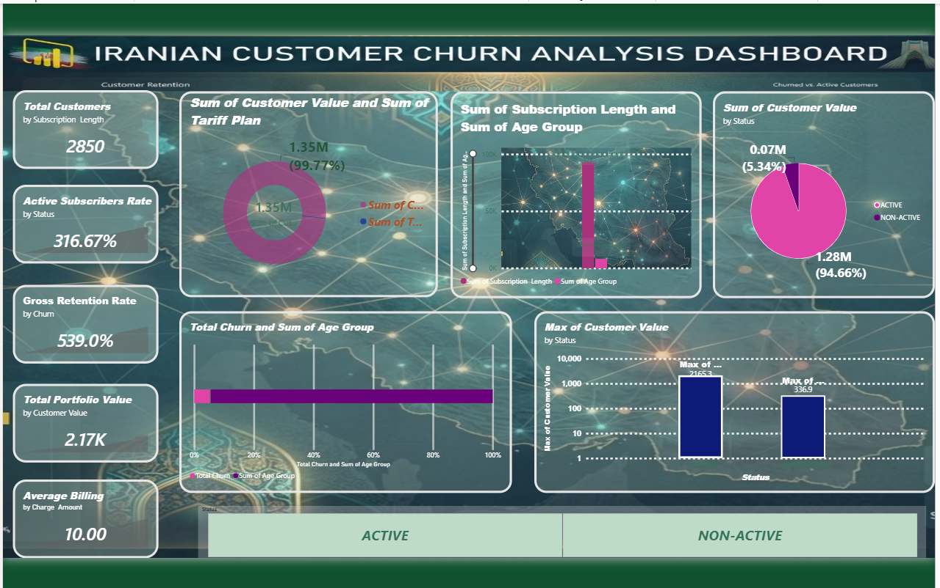

PAGE1 :EXECUTIVE Kpi Dashboard
Objective: High-level health monitoring for senior leadership to track overall subscriber volume, revenue yield, and baseline churn metrics.
KPIs:
- Total Customers: Count of unique customer records (\(N\)).
- Active Subscriber Rate (%): Percentage of total base with Status == ACTIVE.
- Gross Retention Rate (%): Percentage of total base where Churn == 0.
- Total Portfolio Value: Sum of Customer Value.
- Average Billing Tier: Average of Charge Amount (scaled value index).
Charts & Visualizations:
- Revenue Yield by Tariff Profile (Donut Chart): Displays the proportional sum of Customer Value split by Tariff Plan.
- Subscription Longevity Benchmarks (Clustered bar chart): Distribution of Subscription Length to isolate the most common months of contract maturity.
- Active vs. Non-Active Base Distribution (Pie Chart): Structural breakdown of customer records grouped by Status.
- Churn Leakage by Demographic Bracket (Horizontal Bar Chart): Total counts of Churn == 1 plotted across different Age Group codes.
- Portfolio Value Generation (Box Plot): Displays the dispersion, median, and financial outliers of Customer Value grouped by active vs. non-active cohorts.
Slicers:
Status (Multi-select), Tariff Plan (Dropdown), and Age Group (List).Page 2: Usage & Engagement Overview
Objective: Operational dashboard for engineering and product management teams to monitor network utility metrics, texting frequency, and hardware connection behaviours.
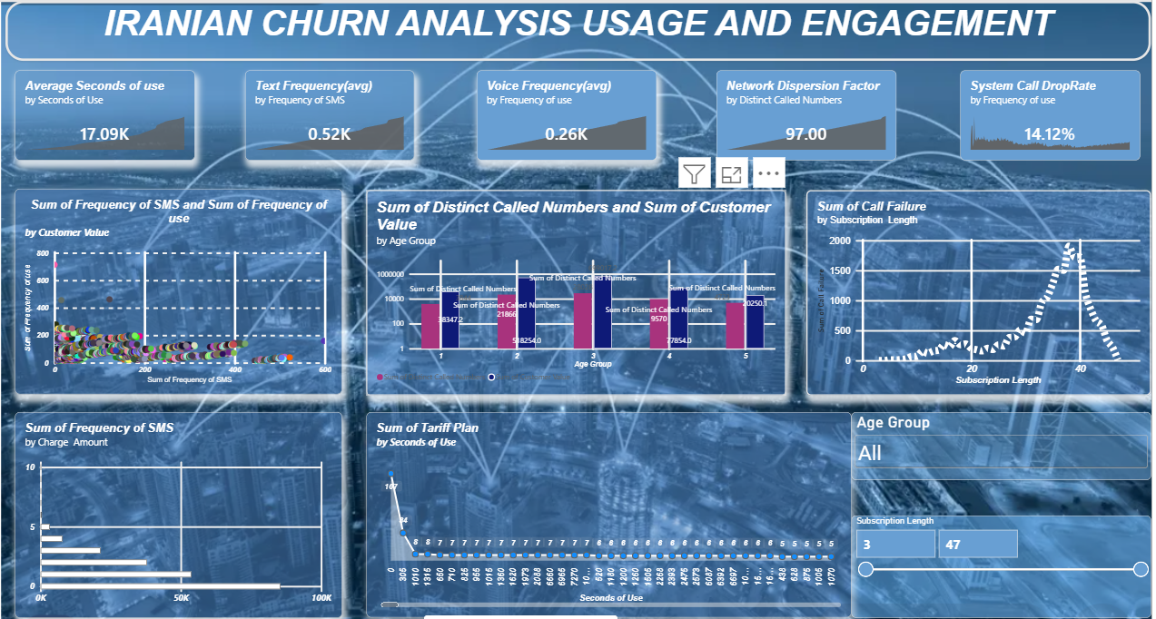
KPIs:
- Average Seconds of Use (MoU): Mean call runtime duration per user.
- Average Voice Frequency: Mean count of call connections generated.
- Average Text Frequency: Mean count of SMS interactions.
- Network Dispersion Factor: Average count of Distinct Called Numbers.
- System Call Drop Rate (%): Total Call Failure events divided by cumulative Frequency of use.
Charts & Visualizations:
- Voice vs. Text Consumption Balance (Scatter Plot): Bivariate display mapping Frequency of use on the X-axis against Frequency of SMS on the Y-axis to segment data heavy text-users from talk-heavy users.
- Demographic Network Range Analysis (Clustered Column Chart): Displays the average number of Distinct Called Numbers across different Age Group parameters.
- Call Failure Concentration Across Customer Lifespans (Line Chart): Evaluates whether technological issues (Call Failure) concentrate around new users or mature users by charting it across Subscription Length.
- Texting Adoption Rates by Account Tier (Stacked Bar Chart): Compares text messaging volume (Frequency of SMS) relative to different billing indices (Charge Amount).
- Average Talk-Time Profiles by Subscriber Tier (Area Chart): Evaluates Seconds of Use across varying Tariff Plan structures.
SLICERS:
- Age Group (Multi-select slider),
- Subscription Length (Range slider).
Page 3: Churn Deep-Dive & Risk Analysis
Objective: Tactical analysis engine for the customer success team to identify high-risk indicators, system pain-points, and immediate attrition triggers.
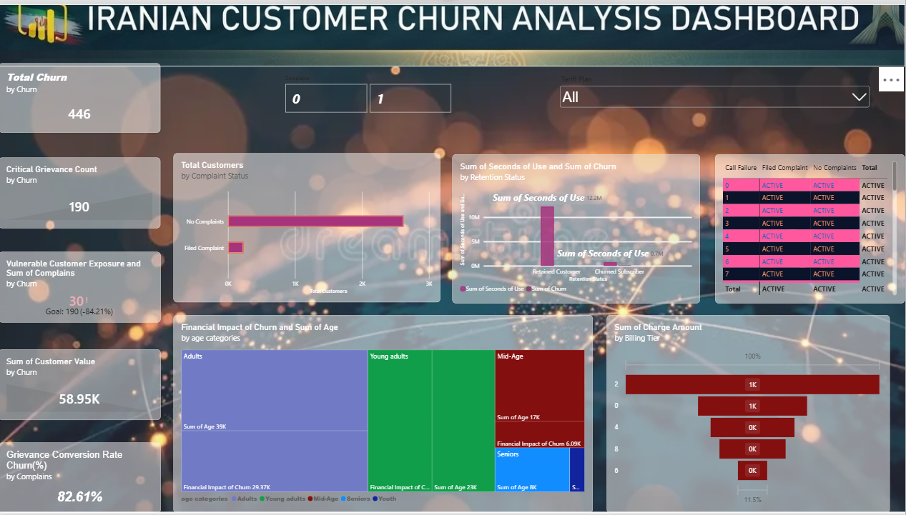
KPIs:
- Total Churned Cohort: Cumulative count of accounts where Churn == 1.
- Critical Grievance Count: Sum of total recorded customer Complains.
- Vulnerable Customer Exposure (Risk Index): Count of users exhibiting high call drop rates (Call Failure > 10) combined with active complaints.
- Financial Impact of Churn: Total sum of Customer Value lost to accounts where Churn == 1.
- Grievance Conversion Rate (%): Percentage of users who filed a complaint (Complains == 1) that ultimately churned.
Charts & Visualizations:
- Grievance Resolution Attrition Correlate (100% Stacked Bar Chart): Shows the proportion of Churned vs. Retained users specifically isolating users who submitted Complains against non-complainants.
- Usage Degradation Thresholds (Box & Whisker Plot): Compares the distribution density of Seconds of Use between the loyal cohort (Churn == 0) and the churned cohort (Churn == 1) to flag the usage drop-off threshold.
- Financial Attrition Matrix by Age (Treemap Chart): Represents total revenue lost (Customer Value where Churn == 1), sized by volume and nested under explicit Age brackets.
- Call Quality Inflection Points (Density Heatmap): Cross-references Call Failure counts against Complains to locate the exact breakdown point where operational bugs spark a formal customer complaint.
- Billing Influx Impact Analysis (Funnel Chart): Tracks customer drop-off metrics ordered sequentially by increasing Charge Amount tiers to calculate price sensitivity ceilings.
Slicers
Multi Slicer: Tariff plan
Tile Slicer: Complains.

